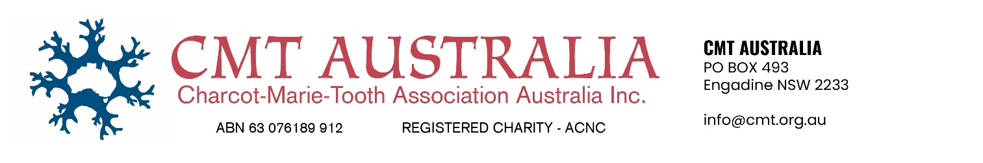

NOMINATION FORM 2025 AGM
I …… ………………………………………………………………….. (Mr. Mrs. Ms.) Please indicate.

Of ……………………………………………………………………………………...................................
(Address)
being a current financial member of CMT AUSTRALIA (Charcot-Marie-Tooth Association of Australia Inc.) wish to nominate for the position of: President, Vice President, Secretary, Treasurer, Committee – 5 positions. Please indicate below which position:
……………………………………………………………………………………………….

Signed: ……………… …………. Date ………………………
1st Member’s signature ………………………………………… 2nd Member’s signature …………………………………………

If you are not attending and wish to appoint a proxy, please fill out the Proxy Form below.

FORM OF APPOINTMENT OF PROXY
I, (print your full
name of member appointing a proxy)

of, …………………………………………………………………………………………………….................. (address)
being a current financial member of the Charcot-Marie-Tooth Association of Australia Inc. hereby appoint

……………………………………………………………………………… (full name of proxy) of

……………………………………………………………………………………………………..................... (address of proxy)
being a current financial member of the Charcot-Marie-Tooth Association of Australia Inc., as my proxy to vote for me on my behalf at the Annual General Meeting of the Association, to be held on November 29th 2025, and at any adjournment of that meeting.
……………………………………….. Date: ……………………………… Signature of member appointing proxy

Please return this form to secretary@cmt.org.au by Thursday 27th November 2025

